**OpenGL project documentation**

Crisan Adrian Gabriel

Group 30433

**Contents**

1. Subject specification
2. Scenario
   1. Scene and objects description
   2. Functionalities
3. Implementation details
   1. Functions and special algorithms
   2. Data structures
   3. Class hierarchy
4. Graphical user interface presentation / user manual
5. Conclusions and further development
6. References
7. **Subject specification**

The subject of the project consists in the photorealistic presentation of 3D objects using OpenGL library. The user directly manipulates by mouse and keyboard inputs the scene of objects. The project implies the visualization of the scene, using a mouse/keyboard controlled camera, translation, rotation and scaling of the objects, or presenting animations of the objects. The project also implements two sources of light, a directional source and a point source, and texture mapping on objects.

1. **Scenario**
   1. **Scene and objects description**

The scene is composed of a skybox and several loaded objects. The scene consists of a ground object surrounded by fences in order to delimit the edges of the ground object, and a few objects in order to exemplify lights, animations, texture mapping and materials. In the center of the scene we have a nanosuit from the Crysis game series, which a high resolution object. We also have Illidan Stormrage from the World of Warcraft universe, presented in two forms, normal and wireframe, we have three boxes of different materials with different properties, we have a tree object, the model of the great hall of the Hogwarts castle, and a sphere in order to show the location of the point light. As for the animations, a Millenium Falcon object rotates around the scene and the user can control a box using the keyboard, the box can move back and front, left and right on the ground and it has a rudimentary collision implemented with several other objects in the scene. Finally, we have the model of the Death Star in the background, just for a dramatic effect. There is also fog implemented.

The main scene view:

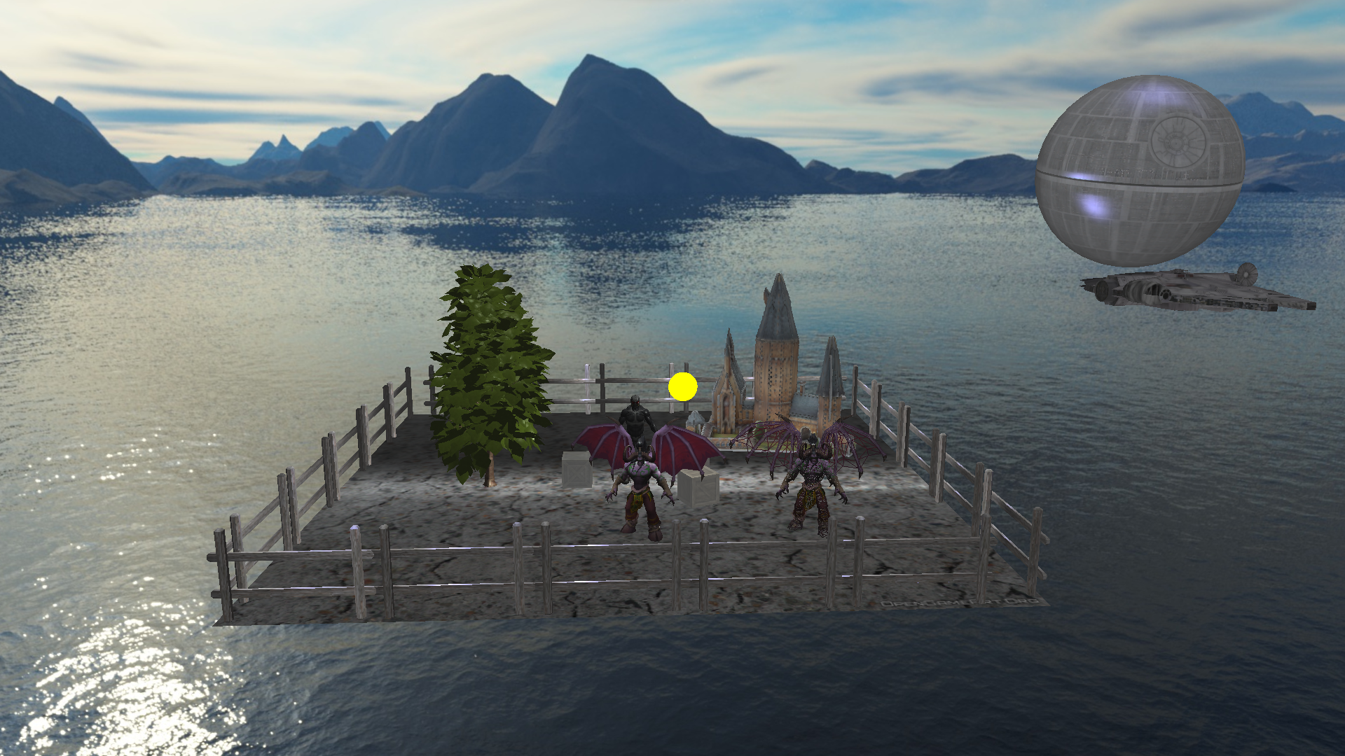

Point and directional lighting:

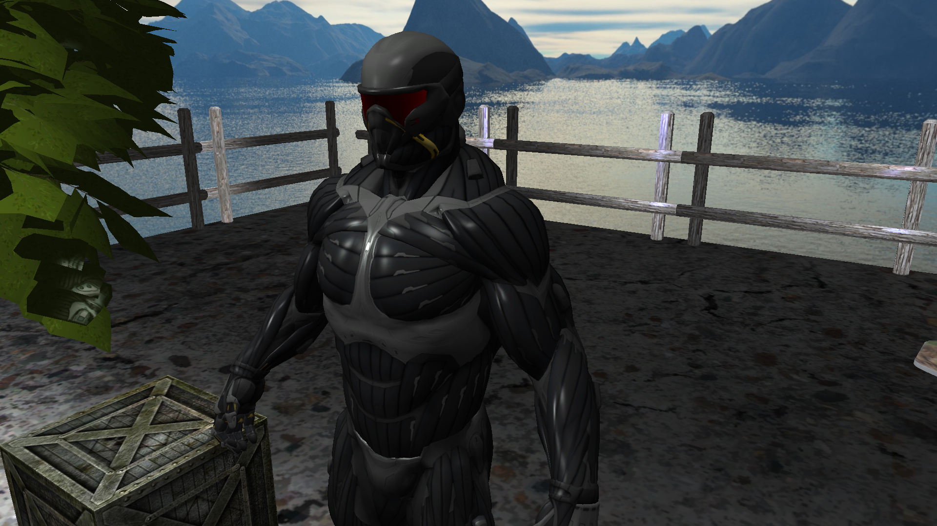

Different materials:

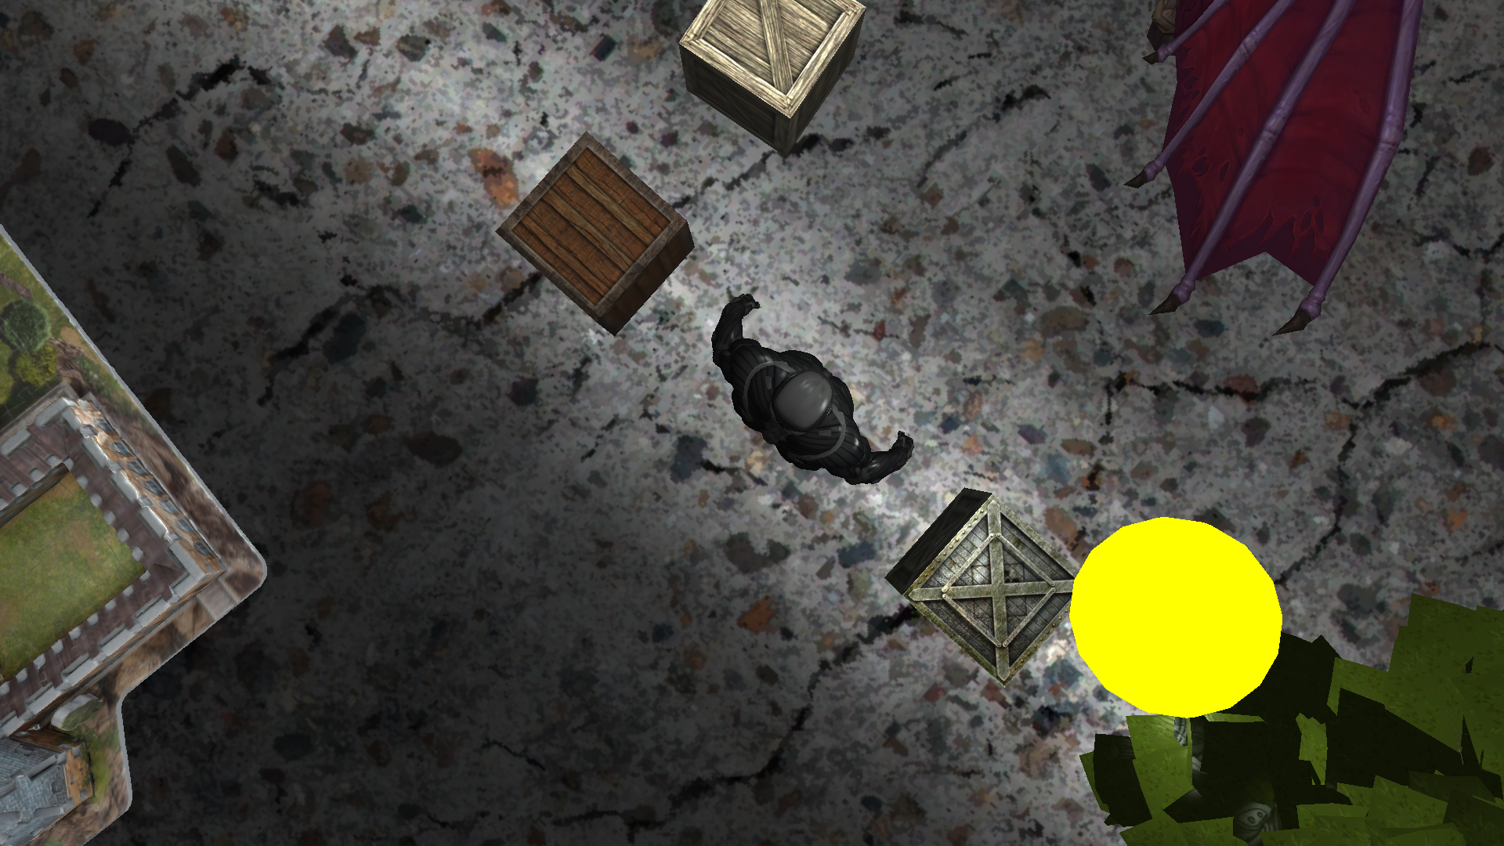

Fog:

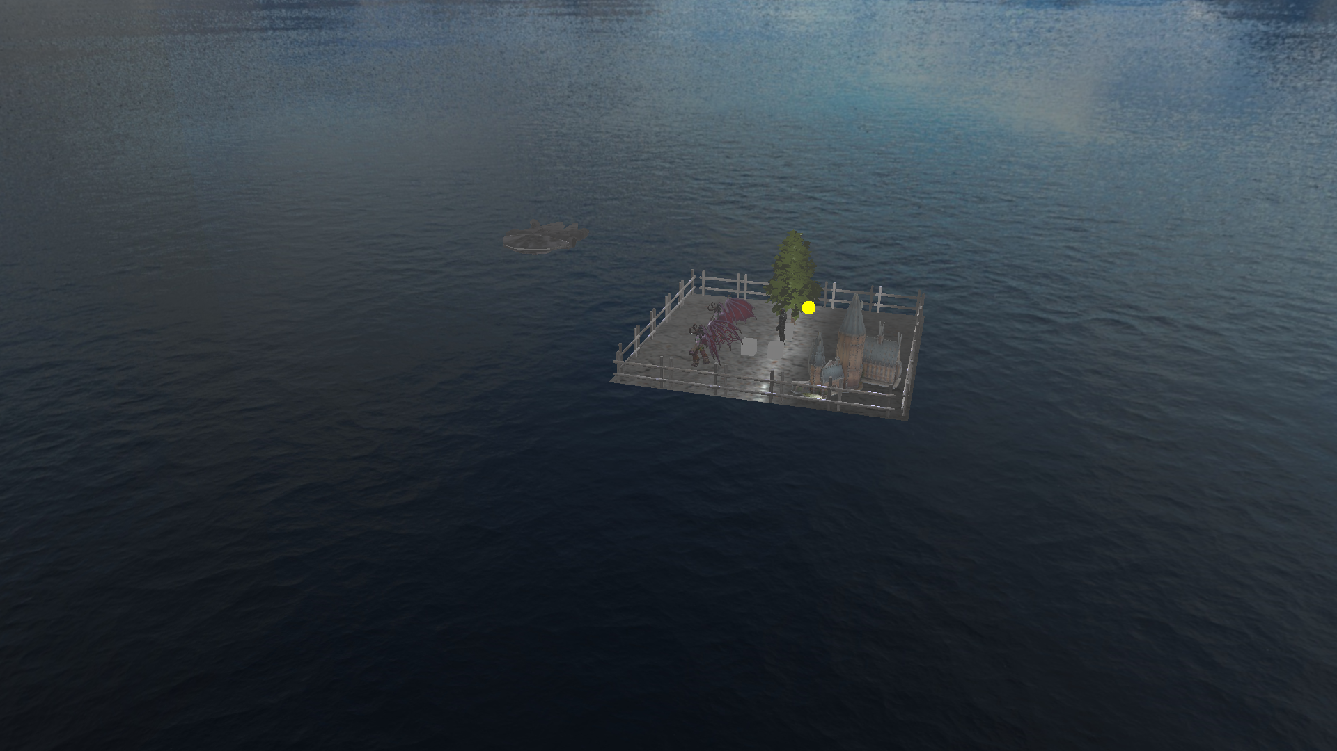

Normal and wireframe representations:

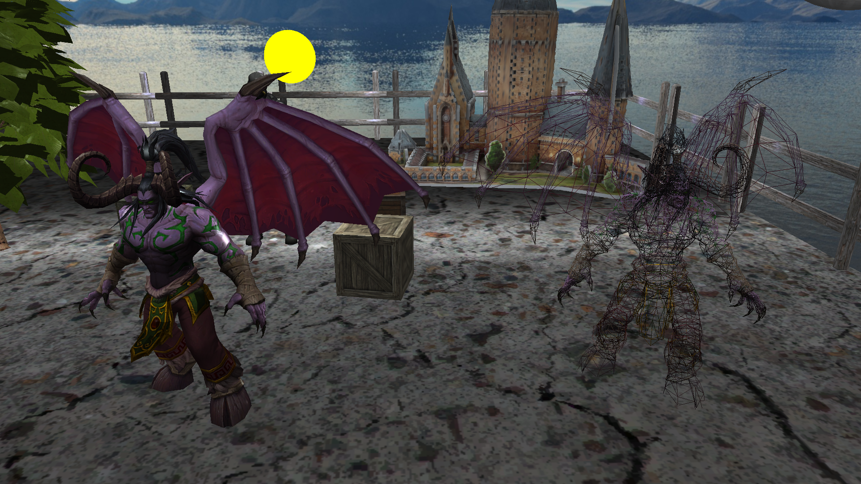

* 1. **Functionalities**

As for the functionalities of the scene, the user can control the direction of the camera view with the mouse, he can also zoom in or out using the mouse scroll, and he can use the keyboard to move the camera in four directions, front, back, left and right. A box can also be controlled from the keyboard.

1. **Implementation details**
   1. **Functions and special algorithms**

In this projects there are four more complex and special algorithms implemented, these being as point light computation, directional light computation, fog computation and camera view Euler angles.

**Point light computation:**

*vec3 CalcPointLight(Light light, vec3 norm, vec3 fragPos, vec3 viewDir)*

*{*

*// ambient*

*vec3 ambient = light.ambient * texture(texture_diffuse1, TexCoords).rgb;*

*// diffuse*

*//vec3 norm = normalize(Normal);*

*vec3 lightDir = normalize(light.position - FragPos);*

*float diff = max(dot(norm, lightDir), 0.0);*

*vec3 diffuse = light.diffuse * diff * texture(texture_diffuse1, TexCoords).rgb;*

*// specular*

*//vec3 viewDir = normalize(viewPos - FragPos);*

*vec3 reflectDir = reflect(-lightDir, norm);*

*float spec = pow(max(dot(viewDir, reflectDir), 0.0), shininess);*

*vec3 specular = light.specular * spec * texture(texture_specular1, TexCoords).rgb;*

*// attenuation*

*float distance = length(light.position - FragPos);*

*float attenuation = 1.0 / (light.constant + light.linear * distance + light.quadratic * (distance * distance));*

*ambient *= attenuation;*

*diffuse *= attenuation;*

*specular *= attenuation;*

*vec3 result = ambient + diffuse + specular;*

*return result;*

*}*

**Directional light computation:**

*vec3 CalcDirLight(DirLight light, vec3 normal, vec3 viewDir)*

*{*

*vec3 lightDir = normalize(-light.direction);*

*// diffuse shading*

*float diff = max(dot(normal, lightDir), 0.0);*

*// specular shading*

*vec3 reflectDir = reflect(-lightDir, normal);*

*float spec = pow(max(dot(viewDir, reflectDir), 0.0), shininess);*

*// combine results*

*vec3 ambient = light.ambient * vec3(texture(texture_diffuse1, TexCoords));*

*vec3 diffuse = light.diffuse * diff * vec3(texture(texture_diffuse1, TexCoords));*

*vec3 specular = light.specular * spec * vec3(texture(texture_specular1, TexCoords));*

*return (ambient + diffuse + specular);*

*}*

**Fog computation:**

*float computeFog() {*

*float fogDensity = 0.01f;*

*float fragmentDistance = length(FogFrag);*

*float fogFactor = exp(-pow(fragmentDistance * fogDensity, 2));*

*return clamp(fogFactor, 0.0f, 1.0f);*

*}*

And in the main:

*float fogFactor = computeFog();*

*vec4 fogColor = vec4(0.5f, 0.5f, 0.5f, 1.0f);*

*FragColor = fogColor * (1 - fogFactor) + vec4(result, 1.0f) * fogFactor;*

**Camera angles:**

*glm::vec3 front;*

*front.x = cos(glm::radians(Yaw)) * cos(glm::radians(Pitch));*

*front.y = sin(glm::radians(Pitch));*

*front.z = sin(glm::radians(Yaw)) * cos(glm::radians(Pitch));*

*Front = glm::normalize(front);*

*Right = glm::normalize(glm::cross(Front, WorldUp));*

*Up = glm::normalize(glm::cross(Right, Front));*

* 1. **Data structures**

There are a few data structures used in order to optimize and ease the access to information.

These two data structures are used in the Mesh class.

*struct Vertex {*

*// position*

*glm::vec3 Position;*

*// normal*

*glm::vec3 Normal;*

*// texCoords*

*glm::vec2 TexCoords;*

*// tangent*

*glm::vec3 Tangent;*

*// bitangent*

*glm::vec3 Bitangent;*

*};*

*struct Texture {*

*unsigned int id;*

*string type;*

*string path;*

*};*

These three data structures are used in the shaders.

*struct Light {*

*vec3 position;*

*vec3 ambient;*

*vec3 diffuse;*

*vec3 specular;*

*float constant;*

*float linear;*

*float quadratic;*

*};*

*struct DirLight {*

*vec3 direction;*

*vec3 ambient;*

*vec3 diffuse;*

*vec3 specular;*

*};*

*struct Material {*

*sampler2D diffuse;*

*vec3 specular;*

*float shininess;*

*};*

* 1. **Class hierarchy**

There are five classes implemented in the project: a main class, Mesh, Model, Camera and Shader. The main class controls the functionalities of the scene, as well as opening and closing the window. The Mesh class loads the textures of the objects in the memory and creates the mesh to be mapped on the objects. The Model class applies the mesh on the objects and loads them from the .obj file. The Camera class controls the camera and does all the necessary computations. The Shader class is a helper class that loads the shaders and processes the data from them and also sets the necessary uniforms in the shaders.

1. **Graphical user interface presentation / user manual**

When the user runs the executable of the project, a window will open fullscreen and after about 20 seconds, the scene loads. The user can control the direction in which he looks using the mouse, and he can also zoom in or out using the mouse scroll, or he can control the camera in four directions using the W A S D keys. The user can also control the movement of a box on the ground texture using the I J K L keys.

1. **Conclusions and further development**

In conclusion, the projects implements all the main functionalities of openGL, such as model loading, lighting, basic animations, and also some glfw functions and GLSL for shaders. As further developments one can impement shadow computation, a more advanced collision detection, more complex animations and weather effects.

1. **References**
2. <https://learnopengl.com/> - the project was created following the tutorial found here, and it uses most of the classes presented here
3. <http://assimp.org/> - downloaded library
4. <http://cgis.utcluj.ro/teaching/course/view.php?id=5> – some functions and code taken from the labs
5. <https://stackoverflow.com/> - for various implementations and code errors
6. <https://free3d.com/> - models downloaded
7. <https://www.turbosquid.com/> - models downloaded
8. <https://sketchfab.com/feed> - models downloaded